**How to create closeout reports for auto-reconciled speedtypes**

1. Expand reports combo box in the actions pane.  
   
2. Select Speedtype Recon (No Activity)  
   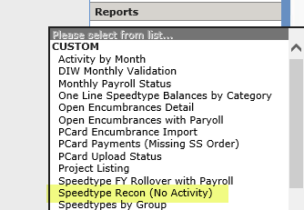
3. Click “create closeout reports” from the actions pane.  
   