How to Receive in Peoplesoft a Fully Received PO
- Go to Louisville.edu website 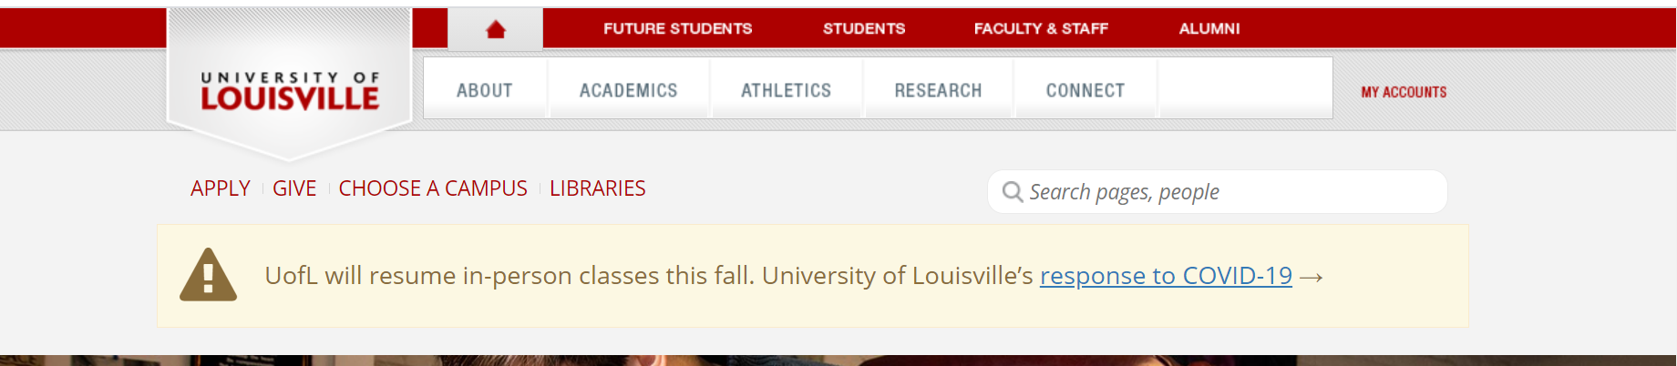
- Click on “My Accounts”
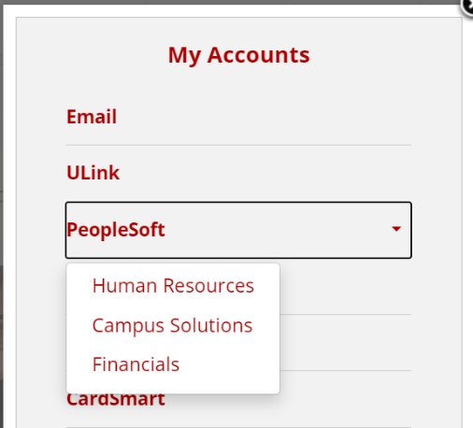
- Click on “Peoplesoft”
- Click on “Financials”

- Once you click Financials - Log into Oracle Peoplesoft 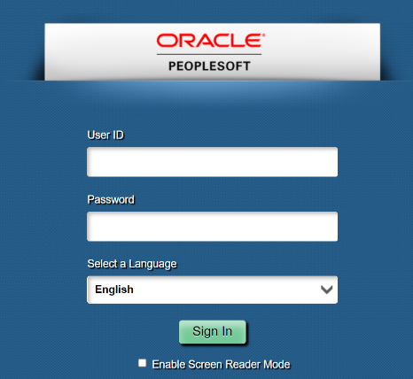
- Find the NavBar located in the Upper Right and click 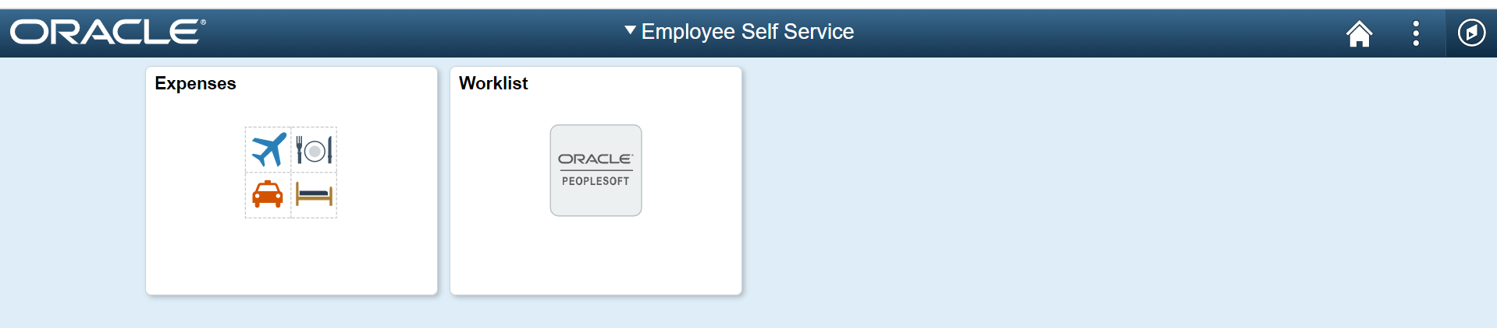
- Click on “Navigator” 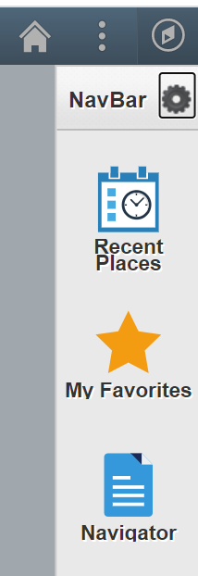
How to Receive in Peoplesoft a Fully Received PO (cont.…)
- Click “Purchasing” 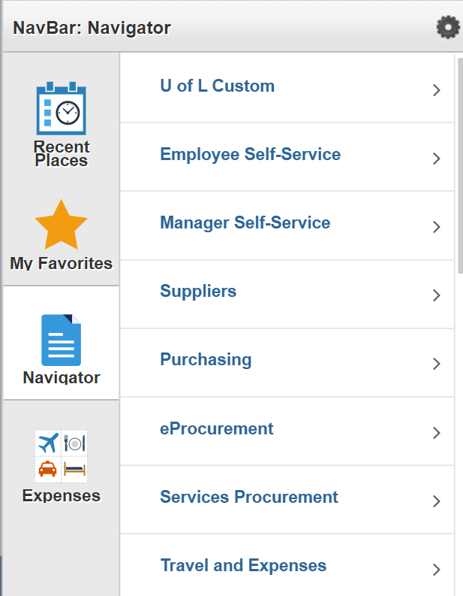
- Click “Receipts” 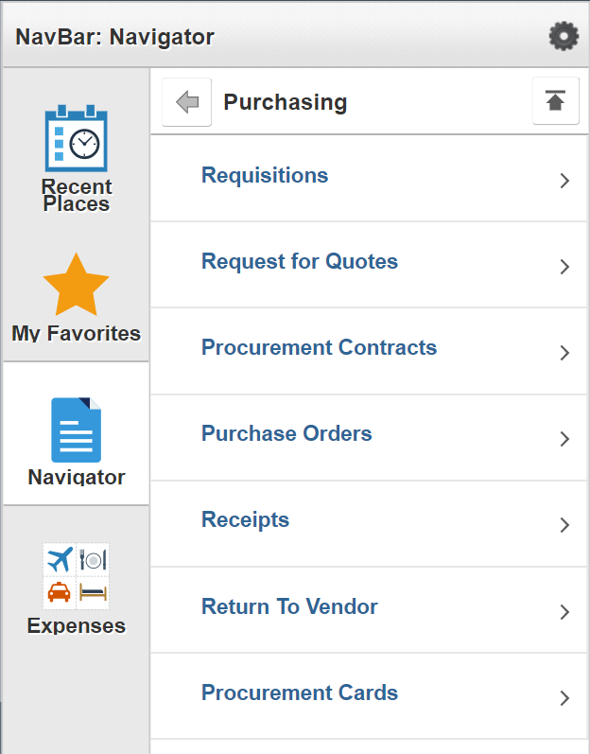
- Click “Add / Update Receipts” 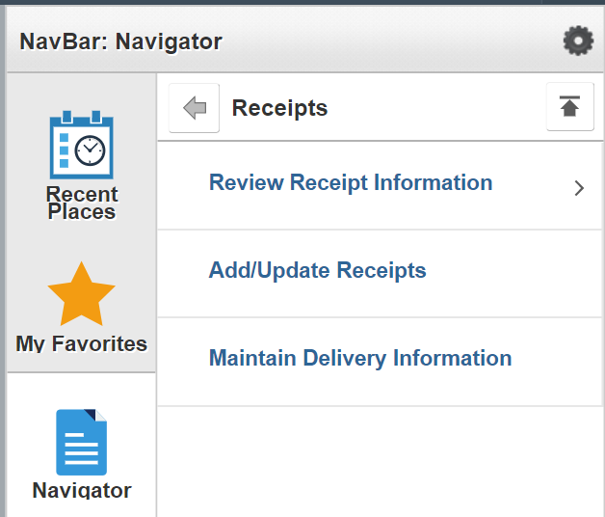

How to Receive in Peoplesoft a Fully Received PO (cont.…)

- Click “Add” 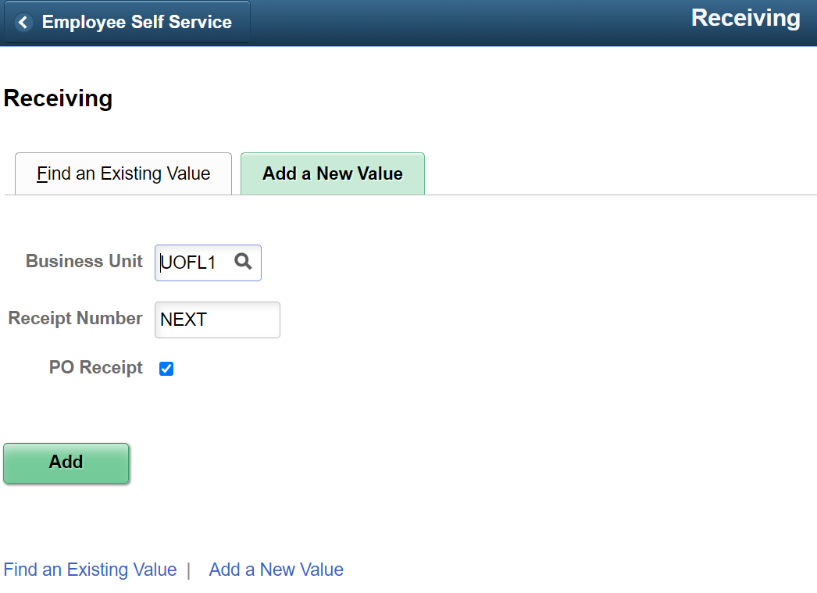
- ID = Enter PO Number 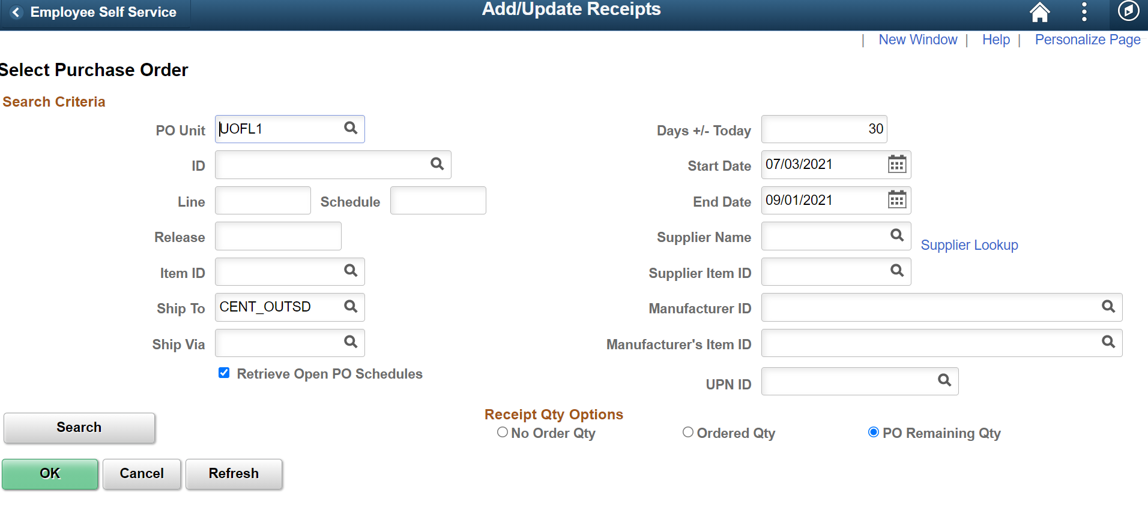
- Make Sure Ship To is Blank
- Click “Search”
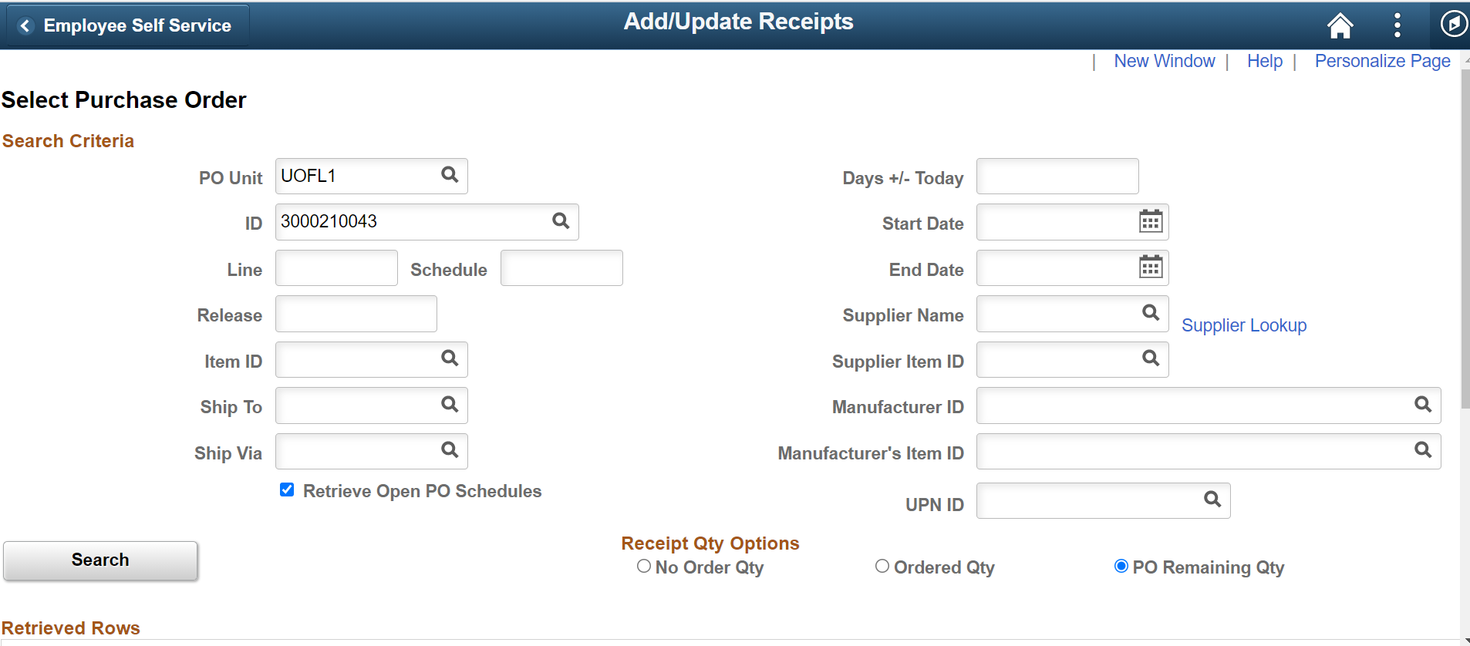
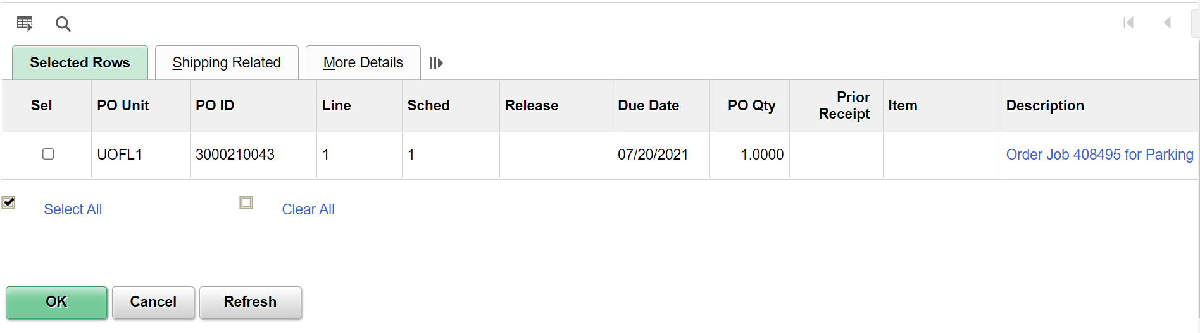

How to Receive in Peoplesoft a Fully Received PO (cont.…)

- Select Item to Receive – if more than one (1) – Select All 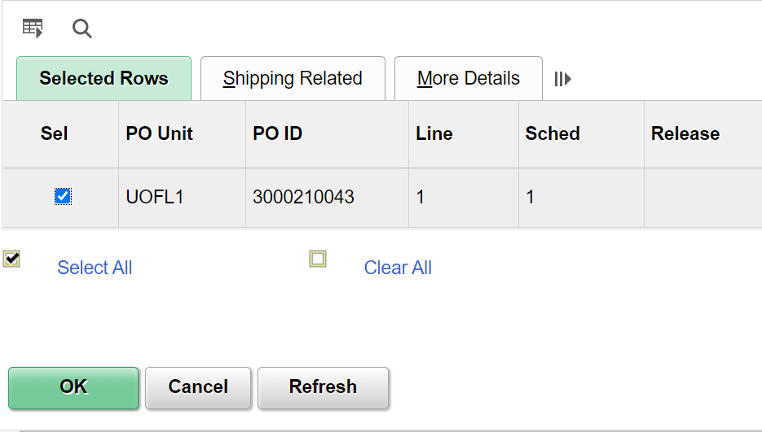
- Click “OK”
- Click “Save” 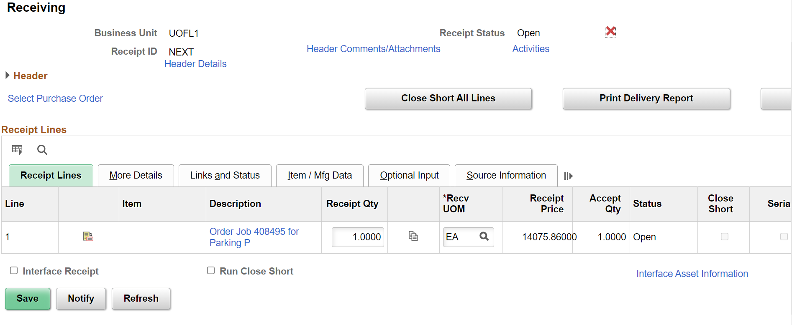
- After you click “Save” – Peoplesoft will generate a Receipt ID – see below as an example:
